Question 1
Q. : What Do You Mean By RESTful Web Services?
Ans : RESTful Web Services Are Web Services Based On The REST (Representational State Transfer) Architecture.
They Allow Communication Between Client And Server Using Standard HTTP Methods Like GET, POST, PUT, DELETE.
Data Is Usually Exchanged In JSON Or XML Format.
Key Principles:
- Stateless Communication: Each Request From Client To Server Must Contain All Necessary Information.
- Client-Server Separation: Client And Server Are Independent.
- Resource-Based: Everything (User, Product, etc.) Is Treated As A Resource Identified By A URL.
Example:
GET /api/products → Fetch All Products
POST /api/products → Add A New Product

Question 2
Q. : What Is JSON-Server? How We Use It In React?
Ans : JSON-Server Is A Lightweight Tool That Allows You To Create A Fake REST API Quickly Using A Simple JSON File As A Database.
It Is Commonly Used For Frontend Development And Testing Without A Real Backend.
Steps To Use In React:
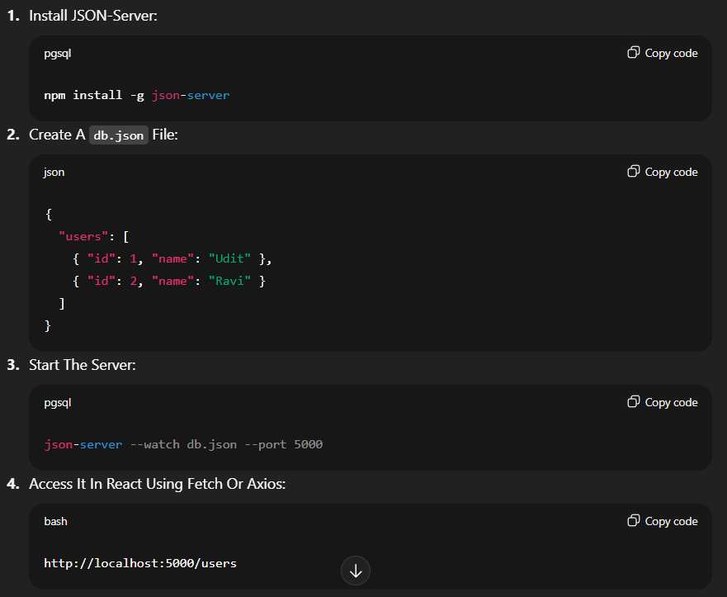

Question 3
Q. : How Do You Fetch Data From A JSON-Server API In React? Explain The Role Of fetch() Or axios() In Making API Requests.
Ans :
Using fetch():
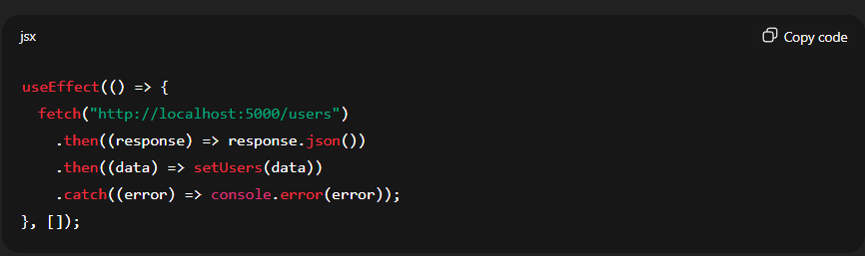
Using axios():
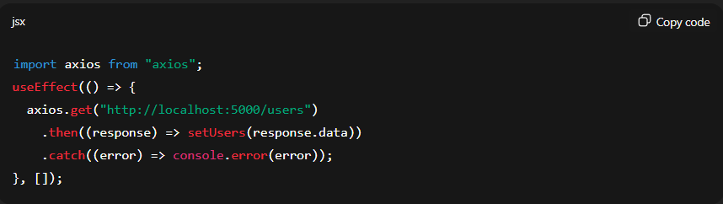

Role Of fetch() / axios():
- Both Are Used To Make HTTP Requests To APIs.
- fetch() Is A Built-In JavaScript Method, While axios() Is A Third-Party Library Offering Extra Features Like Interceptors And Automatic JSON Parsing.

Question 4
Q. : What Is Firebase? What Features Does Firebase Offer?
Ans : Firebase Is A Backend-as-a-Service (BaaS) Platform Developed By Google That Helps Developers Build, Host, And Manage Web And Mobile Apps Easily.
Key Features:
- Realtime Database & Firestore: Store And Sync Data In Real-Time.
- Authentication: Easy Login With Email, Google, Facebook, etc.
- Hosting: Fast And Secure Static Web Hosting.
- Cloud Storage: For Storing User Files Like Images Or Videos.
- Cloud Functions: Run Server-Side Logic Without Managing Servers.
- Analytics & Push Notifications: For Tracking And Engaging Users.

Question 5

Q. : Discuss The Importance Of Handling Errors And Loading States When Working With APIs In React.
Ans :
Importance:
- When Working With APIs, Requests May Take Time Or Fail Due To Network Issues.
- Proper Handling Improves User Experience And App Stability.
Best Practices:
- Show A Loading Spinner Or Message While Data Is Being Fetched.
- Display Error Messages If The Request Fails.
- Use Try...Catch (With async/await) Or .catch() To Handle API Errors Gracefully.
